



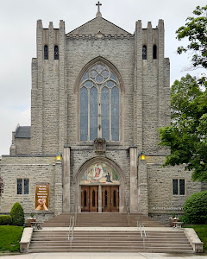
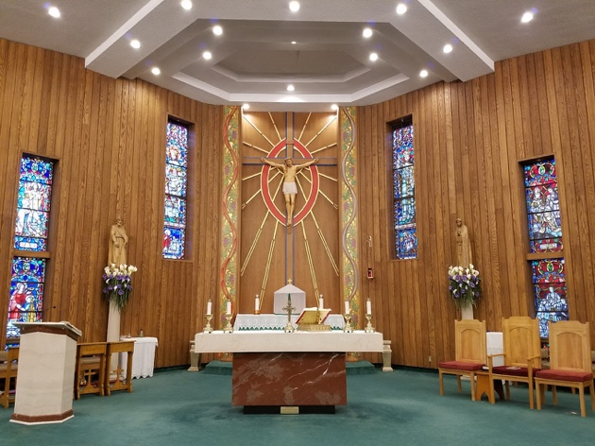
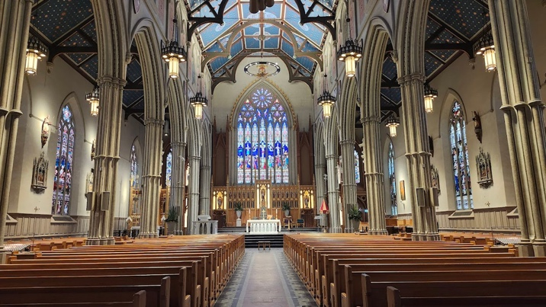
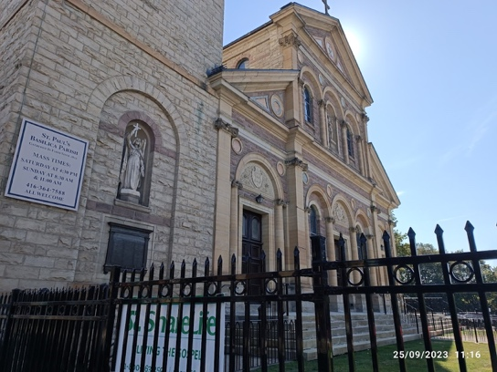
REGISTRATION REQUIRED
Email: torontodevp@gmail.com
Subject Line: Jubilee Walk TO
St. Paul’s Basilica (Toronto)
St. Michael’s Cathedral Basilica (Toronto)
Blessed Sacrament Church (Toronto)
St. Edward the Confessor Parish (North York)
Toronto’s Jubilee Pilgrimage
Saturday, October 18th, 2025
BECOME A PILGRIM OF HOPE
Walk and Ride (the TTC) with us to
“Turn Debt into Hope”
Let’s journey north, along Yonge St., to be united at each stop in prayer and reflection for justice and peace.
Start time: 11:30 am at St. Paul’s Basilica, 83 Power St. Toronto (no parking onsite)
Final stop: in time for 4:30 pm Mass at St. Edward the Confessor, 75 Churchill Avenue
Accessibility accommodations available, let us
know the best way to include you.
Snacks will be provided along the walk.
Pizza and social after mass in the church hall.
Join us along the way if that is easier for you.

