**BECOMING A CATHOLIC**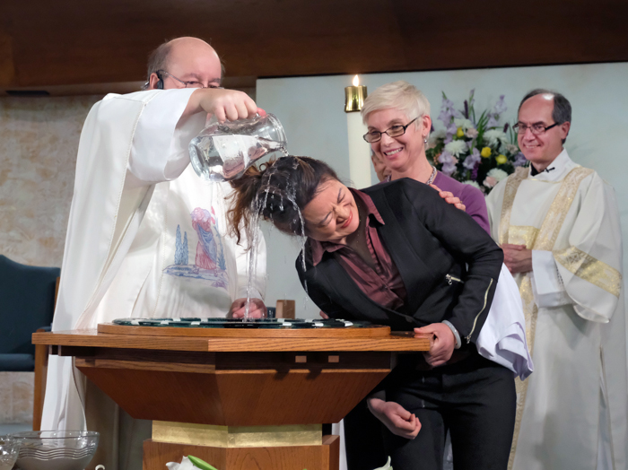

The Right of Christian Initiation of AdultsRCIA) program is available to the non-baptized and to other Christians who would like to become a Catholic.  This program will prepare adults for Baptism, Confirmation, Eucharist, and full reception into the Roman Catholic Church.  Please contact the parish office (416-759-9359 or [*stlawrence.archtoronto@rogers.com*](mailto:stlawrence.archtoronto@rogers.com)) to enroll in the RCIA program.